API Demo - Read Me

Step 1 :

Understanding Project Structure:

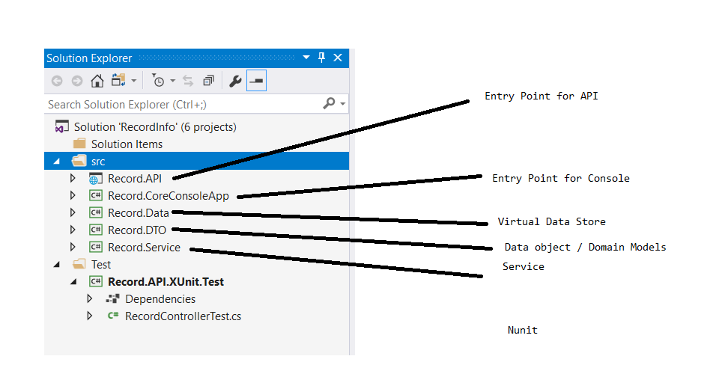

Pre-Requisites

Requires VS 2017 , after opening the solution please make sure to restore all the Nuget packages required to run the Record API.

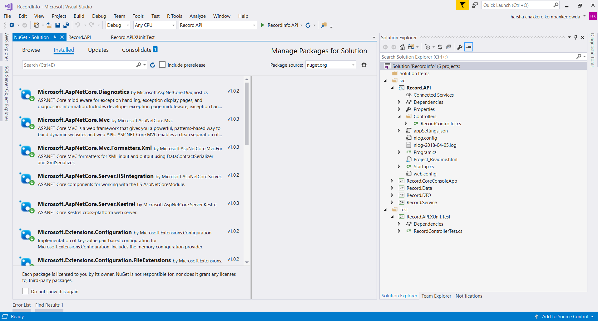

Step 2: Pre-Requisites

Please make sure you have Fiddler or Post Man to simulate the API Calls.

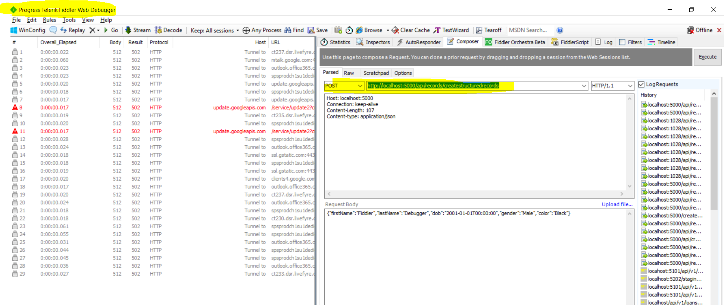

Step 3 : Running the Application with .NET Core Console entry. Circled option should be selected in case using .NET Core native windows Console.

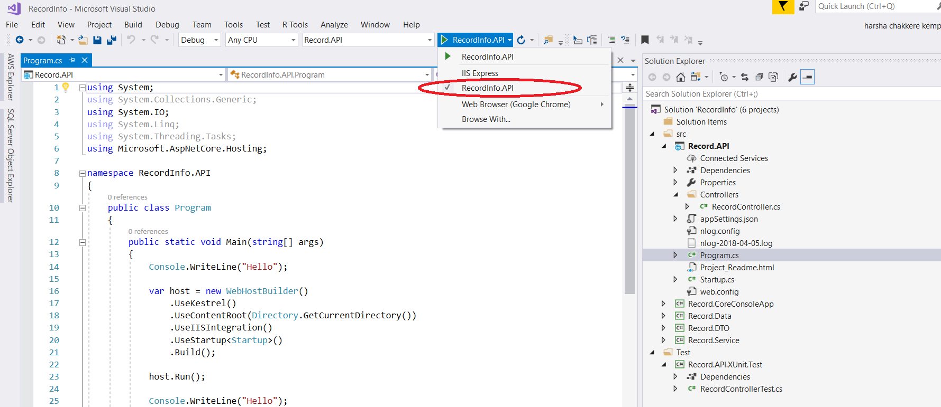

Step 4 : Running the Application with .IIS Express. Circled option should be selected in case using .NET Core on IIS Express.

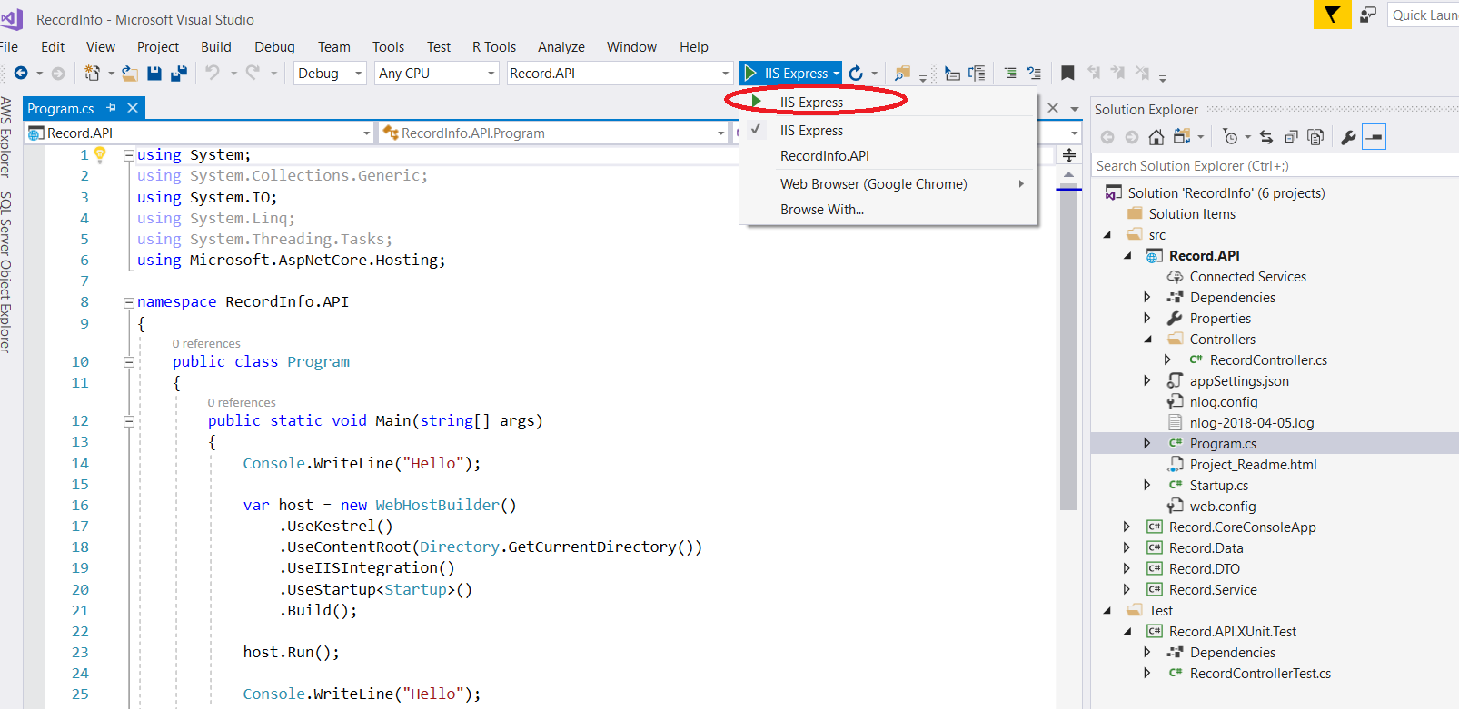

Step 5 : Pre requisite

This solution is build using .NET Core 1.x. Hence make sure the laptop has 1.x Installed before running

the project.

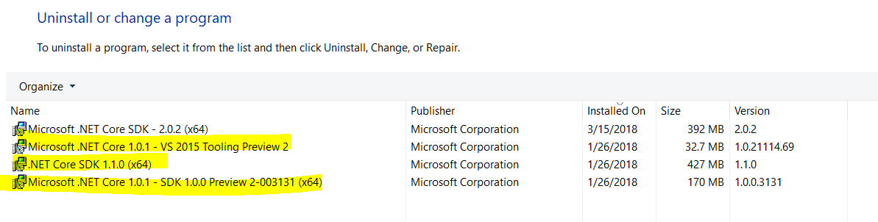

Step 6 : After opening the **RecordInfo** solution file, please build in below order

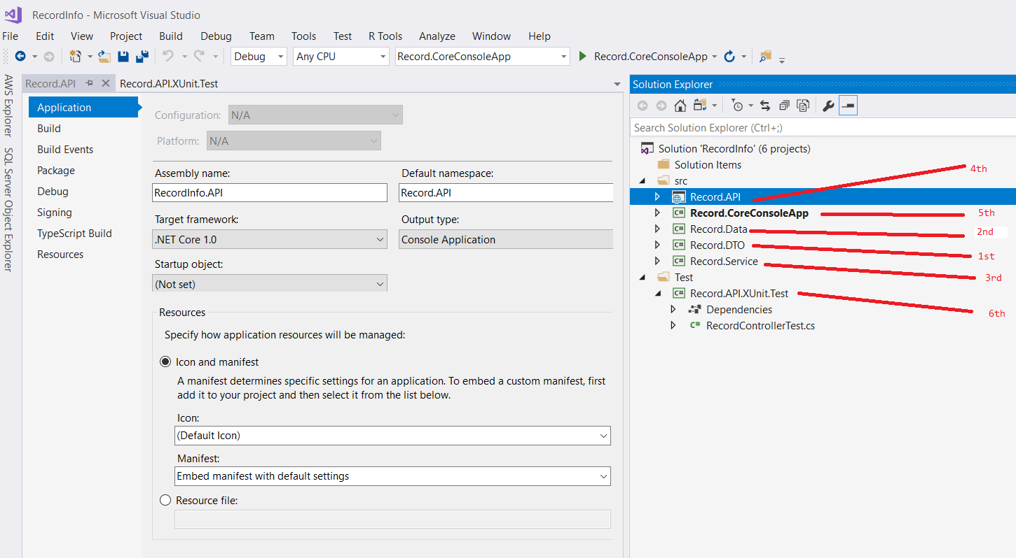

Step 7: As per the assignment, if you want to see the API application output you have to mark “Record.API” project as startup project.

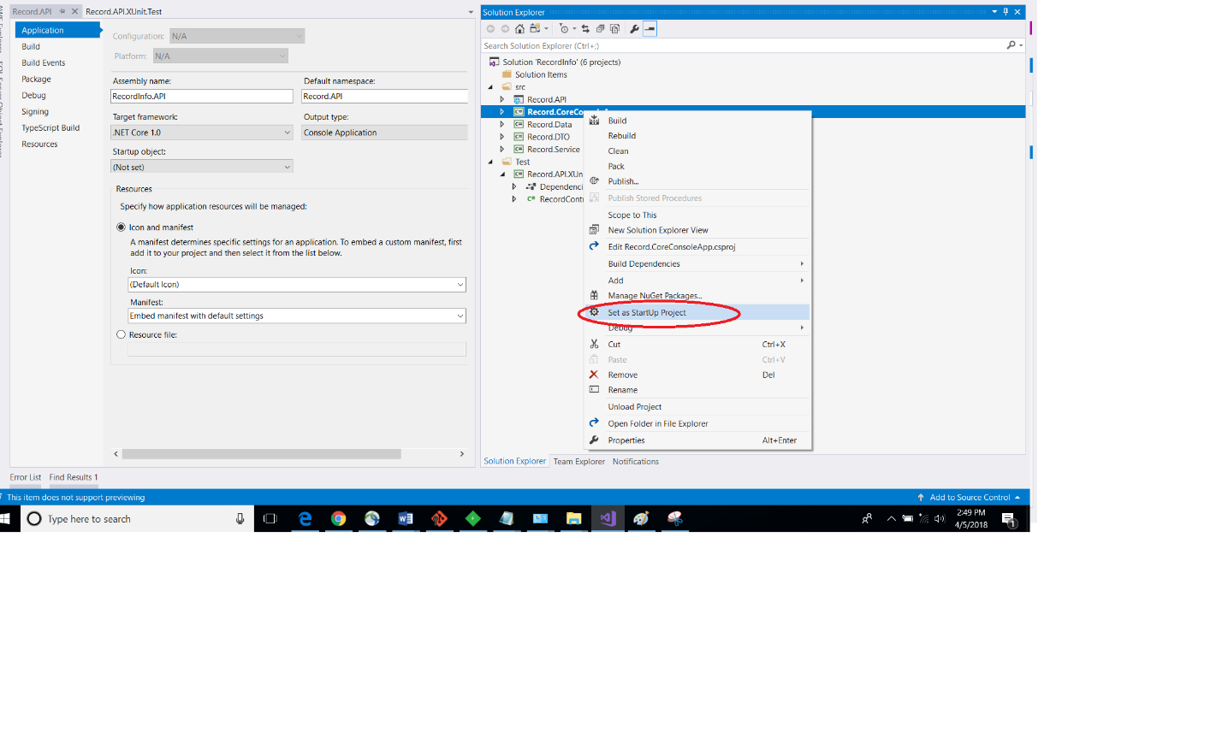

Step 8 : Once you click on Run after above step you would get to see an console app which is running on the <http://localhost:5000/> Port

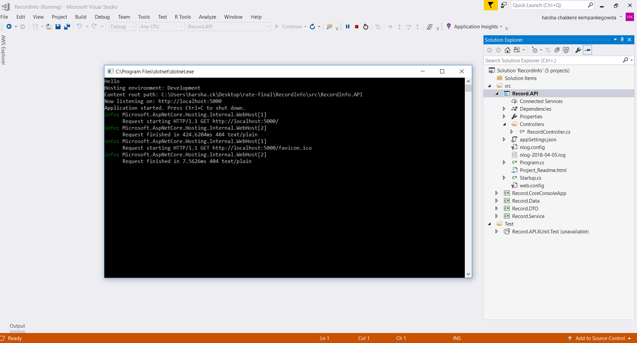

Step 5 : Since few default records already exist You can either you can below URL to get the JSON Data in fiddler or browser

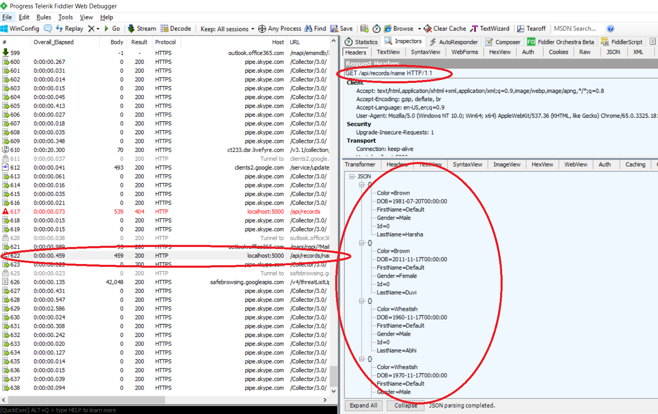

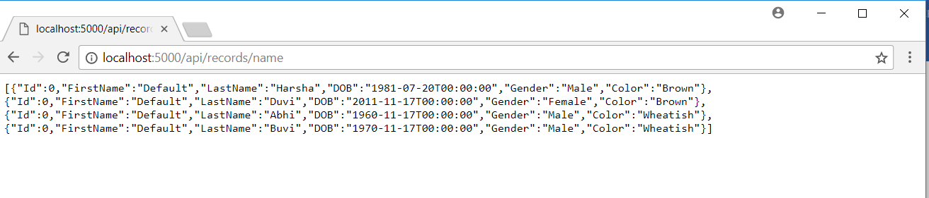

Step 6 :. Inserting a new Record

Option 1 : Strongly typed model

In order insert records you can send POST Message (single record at a time ) ex : Record Model with curly braces

Request URL : <http://localhost:5000/api/records/createstructuredrecords>

Request Body : {"firstName":"Fiddler","lastName":"Debugger","dob":"2018-04-05T00:00:00","gender":"Male","color":"Black"}

Request Header : Content-type: application/json

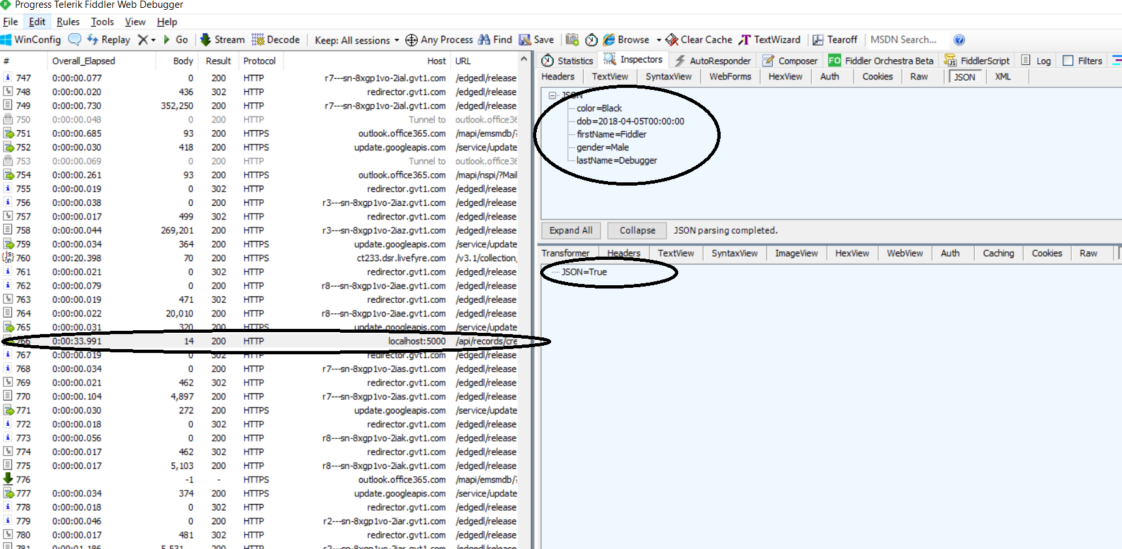

Option 2 : Loosely typed model

In order insert records you can send POST Message (single record at a time ) ex : line with Comma , line with TAB , line with Pipe .

Request URL : http://localhost:5000/api/records/createflatrecords

Request Body : "Fiddler,LastSecond,04/05/2018,Female,Brown"

Request Header : Content-type: application/json

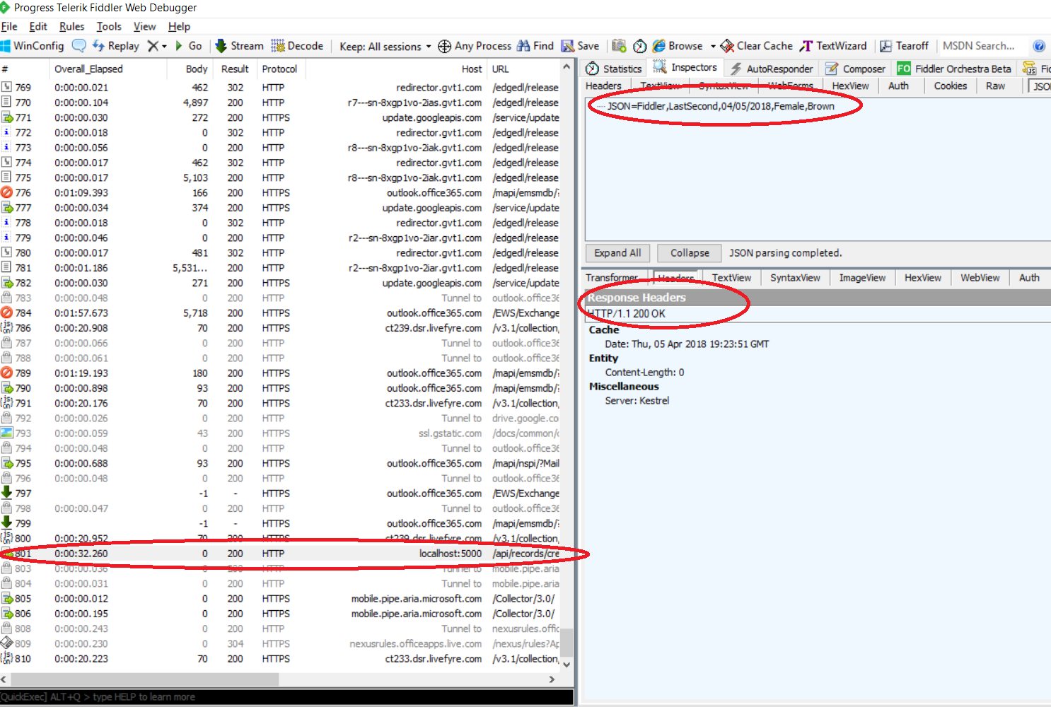

Step 7 : retrieving record with different sorts

Option 1 : sort by gender

Request URL : http://localhost:5000/api/records/gender

Request Body : n/a

Request Header : Content-type: application/json

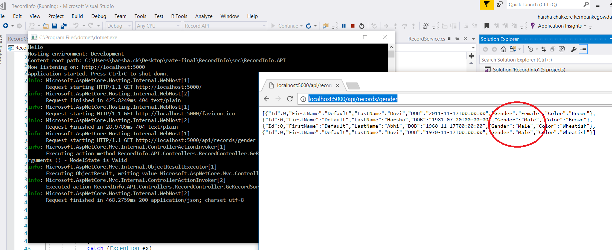

Option 2 : sort by birthdate

Request URL : http://localhost:5000/api/records/birthdate

Request Body : n/a

Request Header : Content-type: application/json

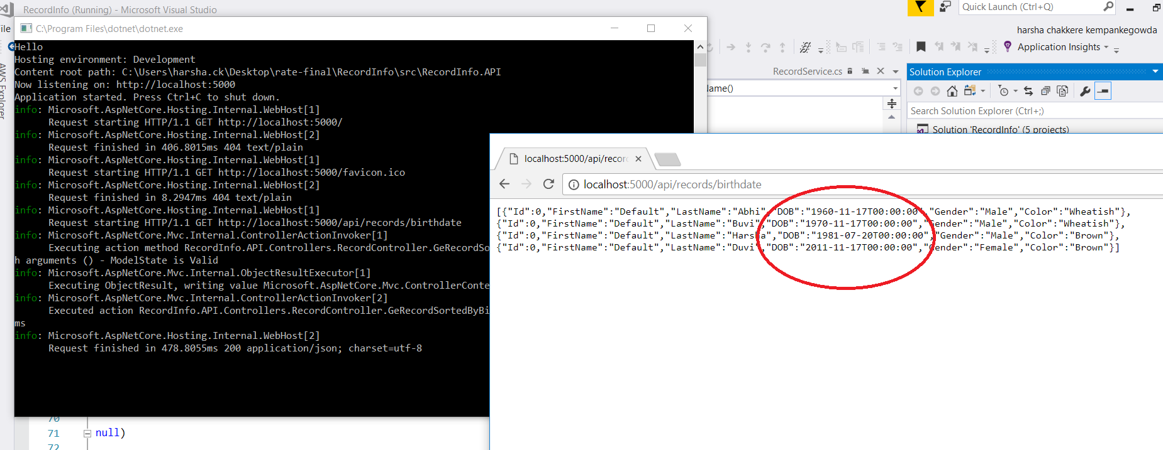

Option 2 : sort by name

Request URL : http://localhost:5000/api/records/name

Request Body : n/a

Request Header : Content-type: application/json

